量产红包

**主模型：**

Game Icon Institute_mode

<https://www.liblib.ai/modelinfo/3c65e0e6d361f2614b263fc5fa4aafad>

**Lora：**

1. 红包RedbagLora（权重默认0.8）

<https://www.liblib.ai/modelinfo/821764b55e7943db90b7cd95c4f25269>

2.Add细节增幅器(权重默认0.2，需要可以往上调)

<https://www.liblib.ai/modelinfo/6524769081394e9aabf41479eb1b4f82>

效果图：

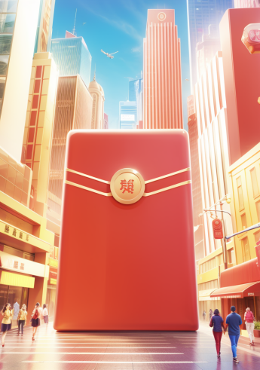 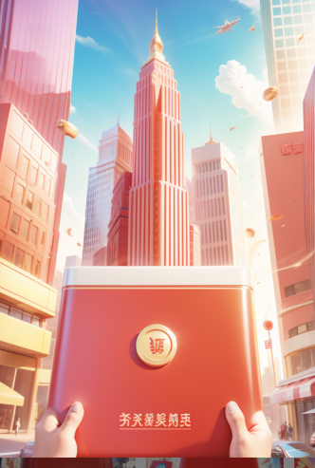 

正面提示词：redbag, city, building, holding, pov hand, look up, details,

负面提示词：paintings, sketches, (worst quality:2), (low quality:2), (normal quality:2), dot, mole, lowres, normal quality, monochrome, grayscale, text, error, cropped, worst quality, low quality, jpeg artifacts, ugly, duplicate, morbid, mutilated, out of frame, extra fingers, mutated hands, poorly drawn hands, poorly drawn face, mutation, deformed, blurry, dehydrated, bad anatomy, bad proportions, extra limbs, mask,((mask))

**再添加下面lora调整风格：**

1.UI设计】MBE风格 | MBE Style

<https://www.liblib.ai/modelinfo/977a42a87937426686045eb3b64e5526>

  

正面提示词：redbag, details,

负面提示词：paintings, sketches, (worst quality:2), (low quality:2), (normal quality:2), dot, mole, lowres, normal quality, monochrome, grayscale, text, error, cropped, worst quality, low quality, jpeg artifacts, ugly, duplicate, morbid, mutilated, out of frame, extra fingers, mutated hands, poorly drawn hands, poorly drawn face, mutation, deformed, blurry, dehydrated, bad anatomy, bad proportions, extra limbs, mask,((mask))

**2.国潮-插画艺术**

**<https://www.liblib.ai/modelinfo/b358438fcbb64bcdb467a31ae245c75f>**

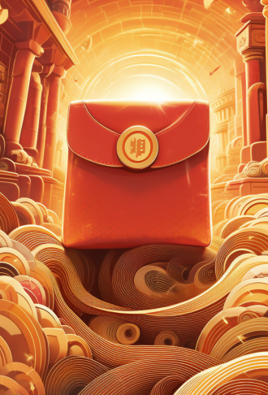  

正面提示词：redbag, details,

负面提示词：paintings, sketches, (worst quality:2), (low quality:2), (normal quality:2), dot, mole, lowres, normal quality, monochrome, grayscale, text, error, cropped, worst quality, low quality, jpeg artifacts, ugly, duplicate, morbid, mutilated, out of frame, extra fingers, mutated hands, poorly drawn hands, poorly drawn face, mutation, deformed, blurry, dehydrated, bad anatomy, bad proportions, extra limbs, mask,((mask))

3.3D简约人物3dhuman_Lora

<https://www.liblib.ai/modelinfo/420ed56b05d94bac99ff78095afcf8c1>

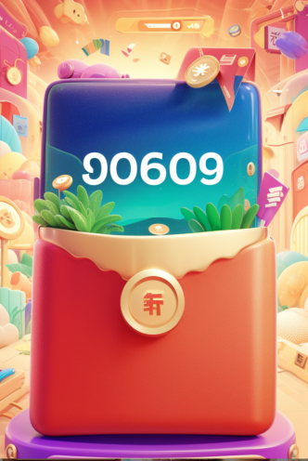 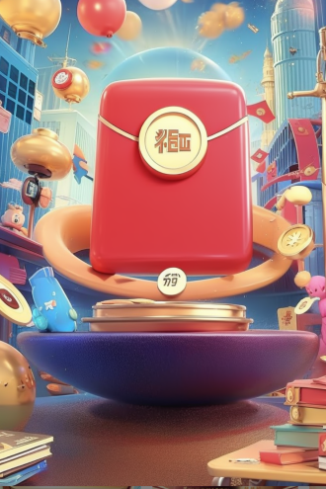 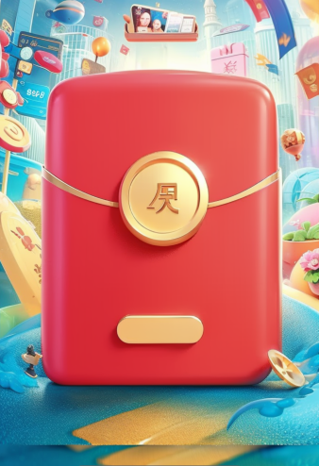

正面提示词：redbag, details,

负面提示词：paintings, sketches, (worst quality:2), (low quality:2), (normal quality:2), dot, mole, lowres, normal quality, monochrome, grayscale, text, error, cropped, worst quality, low quality, jpeg artifacts, ugly, duplicate, morbid, mutilated, out of frame, extra fingers, mutated hands, poorly drawn hands, poorly drawn face, mutation, deformed, blurry, dehydrated, bad anatomy, bad proportions, extra limbs, mask,((mask))

1. 【哩布首发】新国潮：恭喜发财

<https://www.liblib.ai/modelinfo/c9d5f77c0f584bd9ad2b7094bb7cfc50>

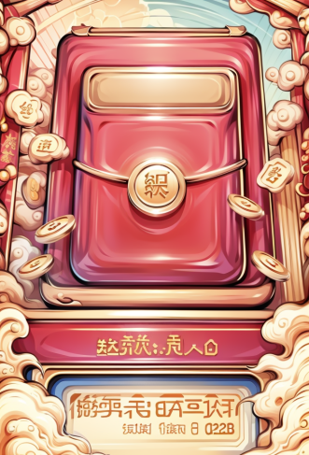  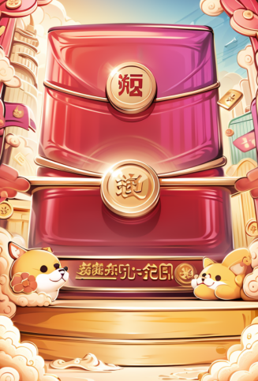

正面提示词：redbag, details,

负面提示词：paintings, sketches, (worst quality:2), (low quality:2), (normal quality:2), dot, mole, lowres, normal quality, monochrome, grayscale, text, error, cropped, worst quality, low quality, jpeg artifacts, ugly, duplicate, morbid, mutilated, out of frame, extra fingers, mutated hands, poorly drawn hands, poorly drawn face, mutation, deformed, blurry, dehydrated, bad anatomy, bad proportions, extra limbs, mask,((mask))

**更换主模效果：**

**Velour 手绘感**

**<https://www.liblib.ai/modelinfo/8c746138216e449f8193372ea1310915>**

 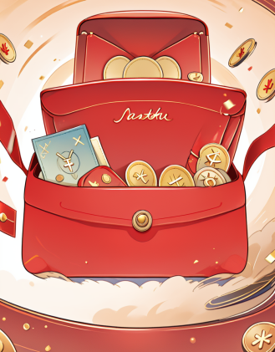

**正面提示词：(masterpiece, best quality:1.3), (redbag:1.5), coin**

**负面提示词：easynegative**

**majicMIX lux 麦橘奇幻**

**<https://www.liblib.ai/modelinfo/c6cfead266b9b38cd8257655ca76dbc2>**

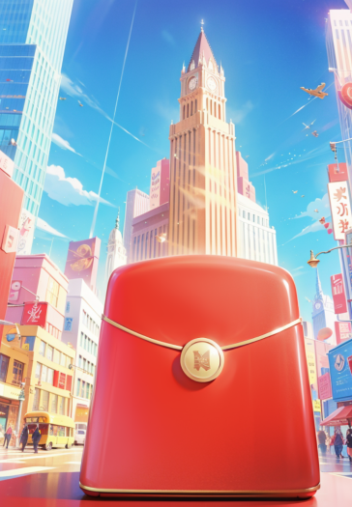 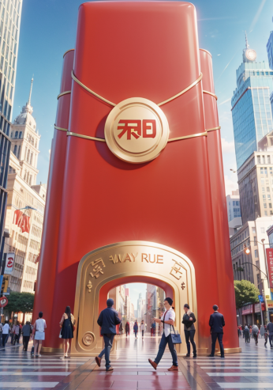

**正面提示词：redbag, city, building, holding, pov hand, look up, details,**

**负面提示词：paintings, sketches, (worst quality:2), (low quality:2), (normal quality:2), dot, mole, lowres, normal quality, monochrome, grayscale, text, error, cropped, worst quality, low quality, jpeg artifacts, ugly, duplicate, morbid, mutilated, out of frame, extra fingers, mutated hands, poorly drawn hands, poorly drawn face, mutation, deformed, blurry, dehydrated, bad anatomy, bad proportions, extra limbs, mask,((mask))**